ENDTERM EXAMINATION

Course: Digital Logic Design – CE118
Date: 04/01/2018 - Time: 85 minutes
(Students are allowed to use paper documents only)

Problem 1 (3.5 pts):
in_1, in_2: data inports
Start: signal to start computation
Out: data outport
Done: signal to end computation
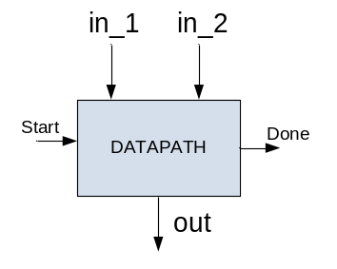
Use the circuit to compute z as below:
z=0
while z<x do
z = max (2.25x + 0.5y, 0.75y)
end while

With: x = max (a, b) and y = min (a, b).
a, b are inputted through in_1, in_2 ports.
Assume that there are functional units in Datapath as follow: 1 adder, 1 subtractor, 1 min, 1 max, 1 shift left one-bit, 2 shift right two-bits.
- Draw ASM chart (Moore) to compute z above. (1.5 pts)
- Derive state-action table for the ASM above. (1pt)
- Encode the states with natural encoding and use T flip-flop to perform the circuit. Derive the input equations of T flip-flops. (1pt)

Problem 3 (2pts):
Write a sequence of instructions that will compute the value of y = x² (3x+5) for a given x, using:
- Two-address instructions. (1pt)
- Three-address instructions. (1pt)
Assume that a register file is available and x is stored at address X in memory. Minimize the number of memory addresses in each case.

Problem 4 (1.5 pts):
Assuming there is one more instruction in the instruction set of the CISC processor 16 bit (given in lecture notes) as below: L new Dst, Src1 with the meaning:
RF[Src1] <- RF[Src1]+1
RF[Dest] <- Mem[Address + RF[Src1] ]
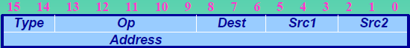
Derive IS flowchart and ASM to perform this instruction.

Problem 4 (3 pts):

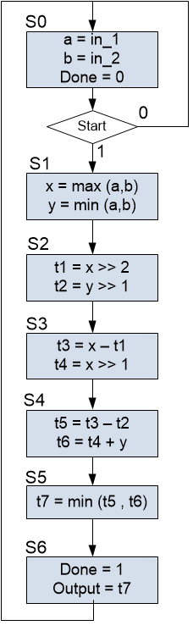
- Perform Register Sharing using Left-edge algorithm (present how to find registers R, no need to draw Datapath) (1pt)
- Perform Register Sharing using Graph Partitioning (present how to find registers R, no need to draw Datapath) (1pt)
- Using result in a), perform Funtional-Unit Sharing using Graph Partitioning (1pt)

----------------------------------------- END -----------------------------------------------------------

Duyệt của Trưởng bộ môn/khoa Cán bộ ra đề

